VIRTUAL DOCTOR ASSISTANCE

Group Members: Amr Elzoeiry 7332555 Halima Asif 7413166 Nasouh Jouejati
  - ECTE 250

TABLE OF CONTENTS
Introduction…………..3
Key functionalities…………4
Simulation Results………….5
Mentor Feedback………………..12

Introduction
Our solution provides patients with ease of communication with the doctor and eliminates the first step of a doctor’s appointment using mainly a pulse and temperature sensor. Our product will be a Virtual Doctor Assistant that will do the initial task of a nurse required before meeting the doctor. This product will be present in the patient’s house, it will have wheels for ease of movement in the patient’s house, the sensors will then measure the pulse and temperature of the patient and send the report to the doctor. We will also have a screen that can be used to have a virtual meeting with the doctor. This virtual meeting makes it easier for the doctor as well to cater to more patients.
There has been an increase in usage of robotics in the healthcare industry and a number of advanced capabilities. These advancements are drawing a good amount of expenditure in the business. The COVID-19 pandemic has also increased the demand for such telepresence robots. The end user for this kind of mobile product would be in the sector of healthcare, education, and business.
Overall, the virtual doctor assistant using pulse and temperature sensors is an innovative technology that has the potential to revolutionize the way patients receive medical assistance. By providing patients with real-time feedback and recommendations, the system empowers them to take control of their health and make informed decisions about their care.

Key functionalities

 Our method saves time in medical clinics and hospitals
 This decreases nurses tasks, giving them time for other tasks
 This gives people with disabilities and time constraints a chance to finish their medical issues faster.

Simulation result
FLOWCHART
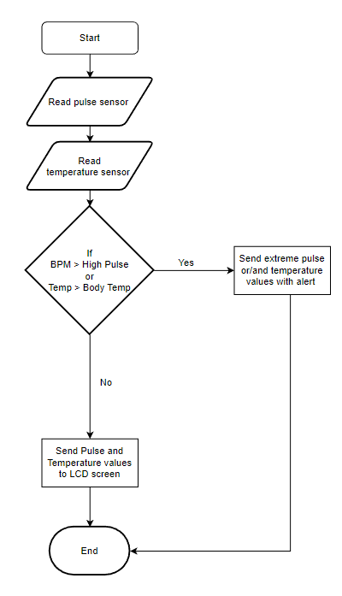

BLOCK DIAGRAM:
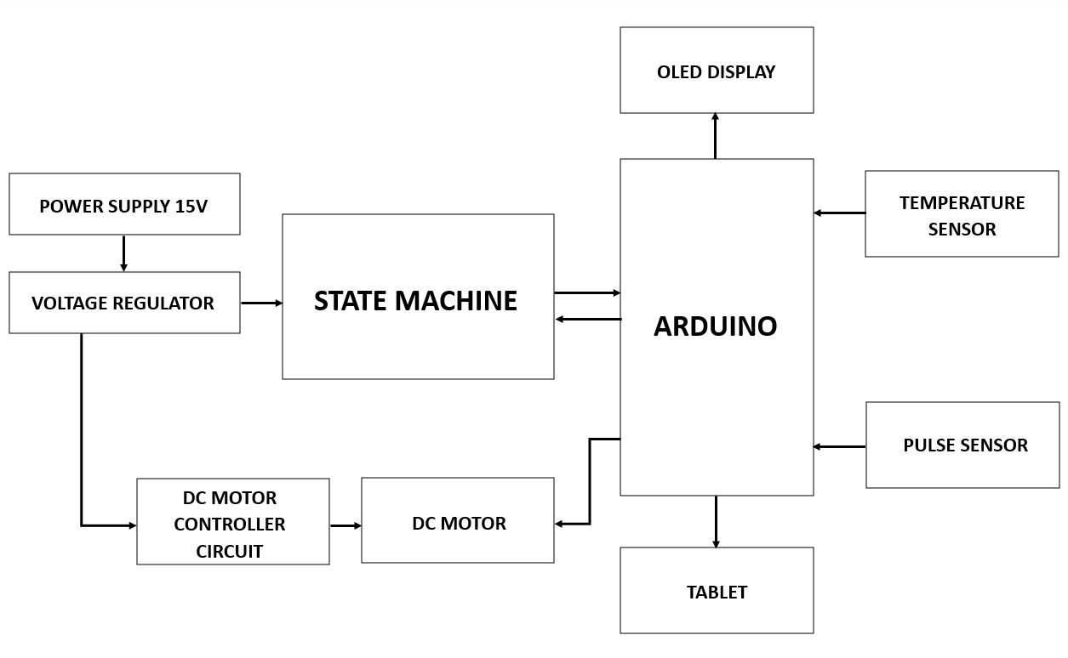
As you can see above are the components needed to make our project.

STATE DIAGRAM
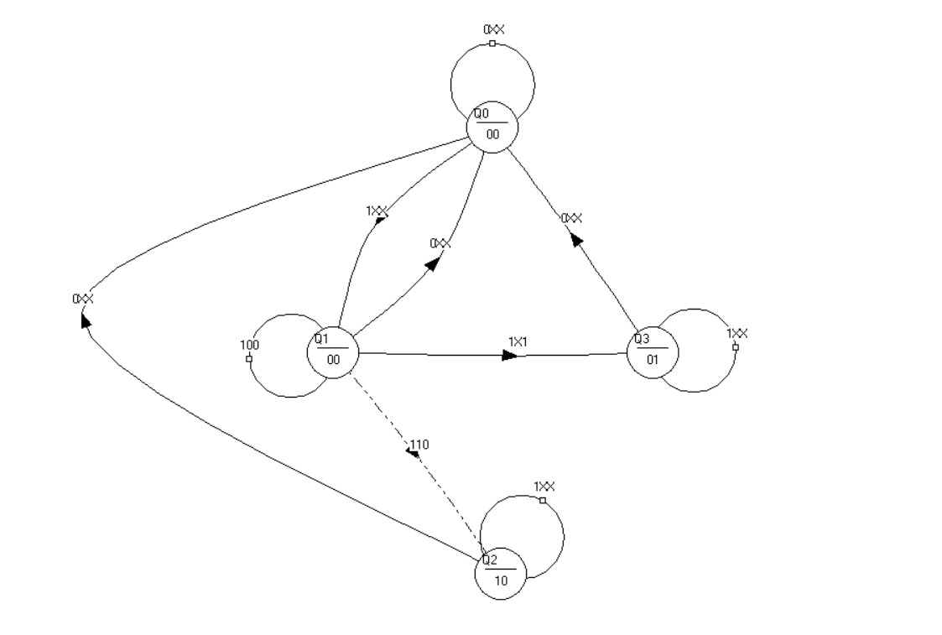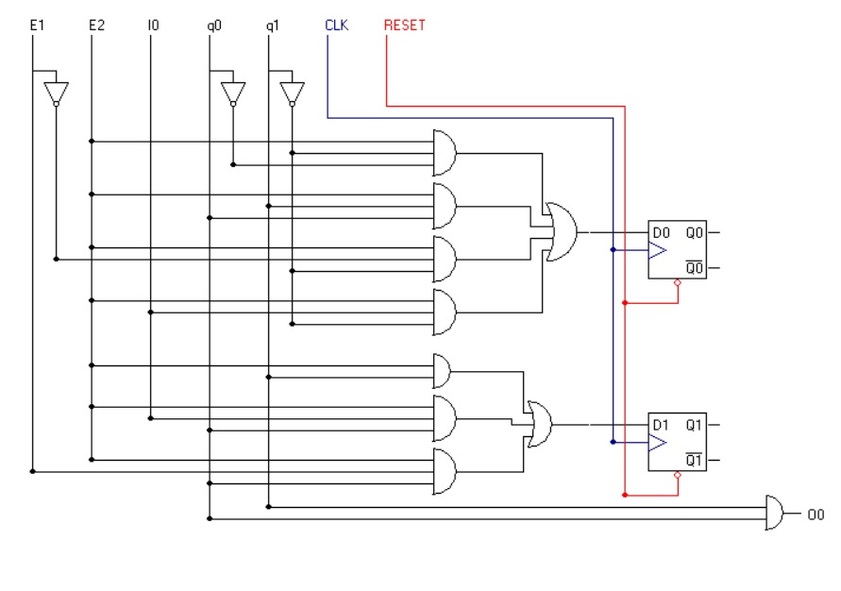

Timing Diagram:

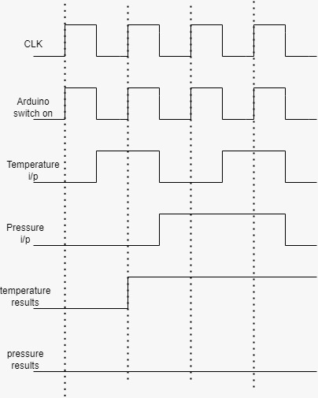
This timing diagram is done for 4 clock cycles. As we can see there are 3 inputs and 2 outputs. The second output only goes up when there is an abnormality in the pulse. As we can see there is no such case in the first 4 cycles but there will be in the following clock cycles. Also it is to be noted that the 00 case is not only for the idle state, but also for the Checking State.

TINKERCAD:
The code below simply shows that the working circuit of our project. This does not include the states that the project will follow.

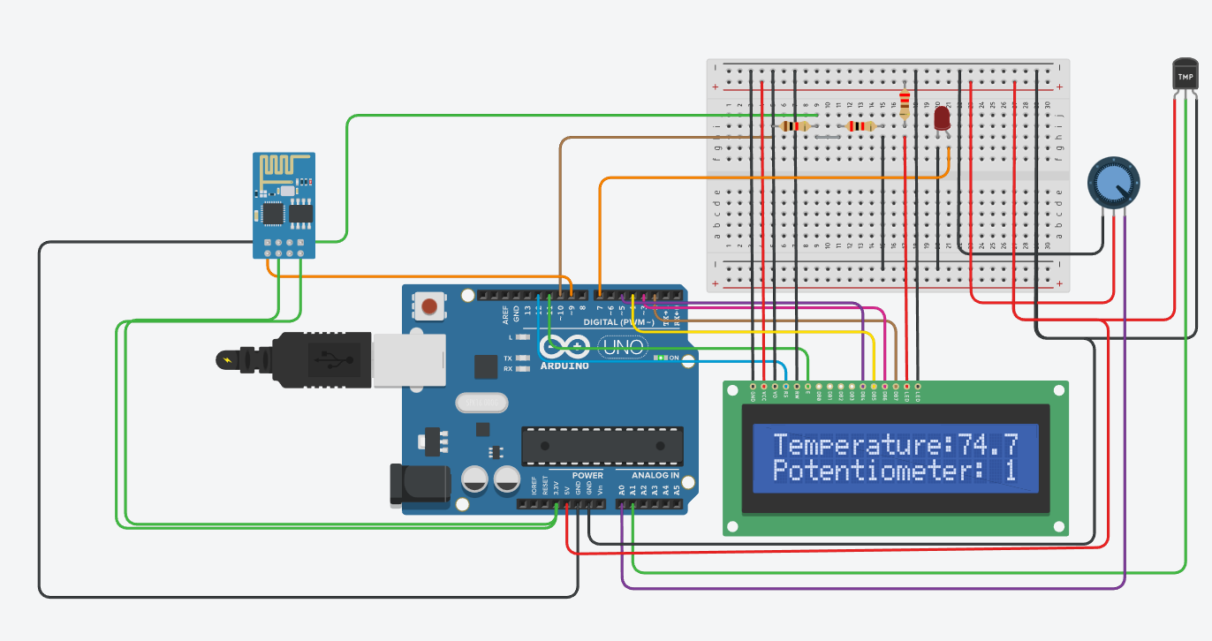

#include <Wire.h>
#include <LiquidCrystal.h>
// initialize the library with the numbers of the interface pins
LiquidCrystal lcd(12, 11, 5, 4, 3, 2);
int tempPin = A1;
int potPin = A0;
int ledPin = 9;
float temp;
int potVal;
void setup() {
// set up the LCD's number of columns and rows:
lcd.begin(16, 2);
// Print a message to the LCD.
lcd.print("Temperature: ");
lcd.setCursor(0, 1);
lcd.print("Potentiometer: ");

pinMode(ledPin, OUTPUT);

// initialize the serial communication
Serial.begin(9600);
}
void loop() {
// read the value from the temperature sensor:
int tempReading = analogRead(tempPin);
// convert the analog reading to Celsius:
temp = (tempReading * 5.0 * 100.0) / 1024.0;
// read the value from the potentiometer:
potVal = analogRead(potPin);
// print the temperature and potentiometer values on the LCD:
lcd.setCursor(12, 0);
lcd.print(temp);
lcd.print(" C");
lcd.setCursor(15, 1);
lcd.print(potVal);
// turn on the LED if the potentiometer reading is greater than 512
if (potVal > 512) {
digitalWrite(ledPin, HIGH);
} else {
digitalWrite(ledPin, LOW);
}
// print the temperature and potentiometer values to the serial monitor
Serial.print("Temperature: ");
Serial.print(temp);
Serial.print(" C, Potentiometer: ");
Serial.println(potVal);
delay(1000);
}

mentor feedback
After gaining insightful feedback from the mentors and judges, we made a good amount of improvements into our project. We improved our flowchart, as shown above, we created a proper test table to make sure our multisim works well and according to the proper measures.
We decided to use a better Wi-Fi chip that may be able to run our entire project, rather than the Arduino UNO with an ordinary Wi-Fi chip, this made no changes in our budget since it was provided by the university.
In this deliverable we included a vital part that was featured in our 3rd deliverable presentation that was Return Of Investment. We also upgraded our milestones for the future deliverables.

